LARS & GenAI Work Accolades

Contents
LARS & GenAI Work Accolades 1
LinkedIn 2
LARS Post 1 2
LARS Post 2 3
AI-OCR Post – Microsoft Kosmos-2.5 MLLM 4
HF-Waitress Server Application Post 4
YouTube – LARS Demo Video – 2671 Views 5
GitHub 6
LARS – 451 Stars and 2489 Views 6
HF-Waitress – 67 Stars and 410 Views 7
HF-Waitress – Acknowledgment from HuggingFace Staff 8
AI-OCR Kosmos 2.5 – 40 Stars and 117 Views 9
Reddit – Post Statistics 10
LARS Post 1 – 194,000 Views, 132 Likes & 179 Shares 10
LARS Post 2 – 52,000 Views, 198 Likes and 259 Shares 10
HF-Waitress Post – 68,000 Views, 236 Likes and 252 Shares 11
AI-OCR Kosmos-2.5 Post – 21,000 Views, 87 Likes and 79 Shares 11
Reddit – Feedback 12
LARS 12
HF-Waitress LLM Server Application 15
AI-OCR Kosmos-2.5 16

LinkedIn

LARS Post 1

Link: https://www.linkedin.com/posts/abheek-gulati_lars-full-demo-activity-7199532556118102016-mi_S

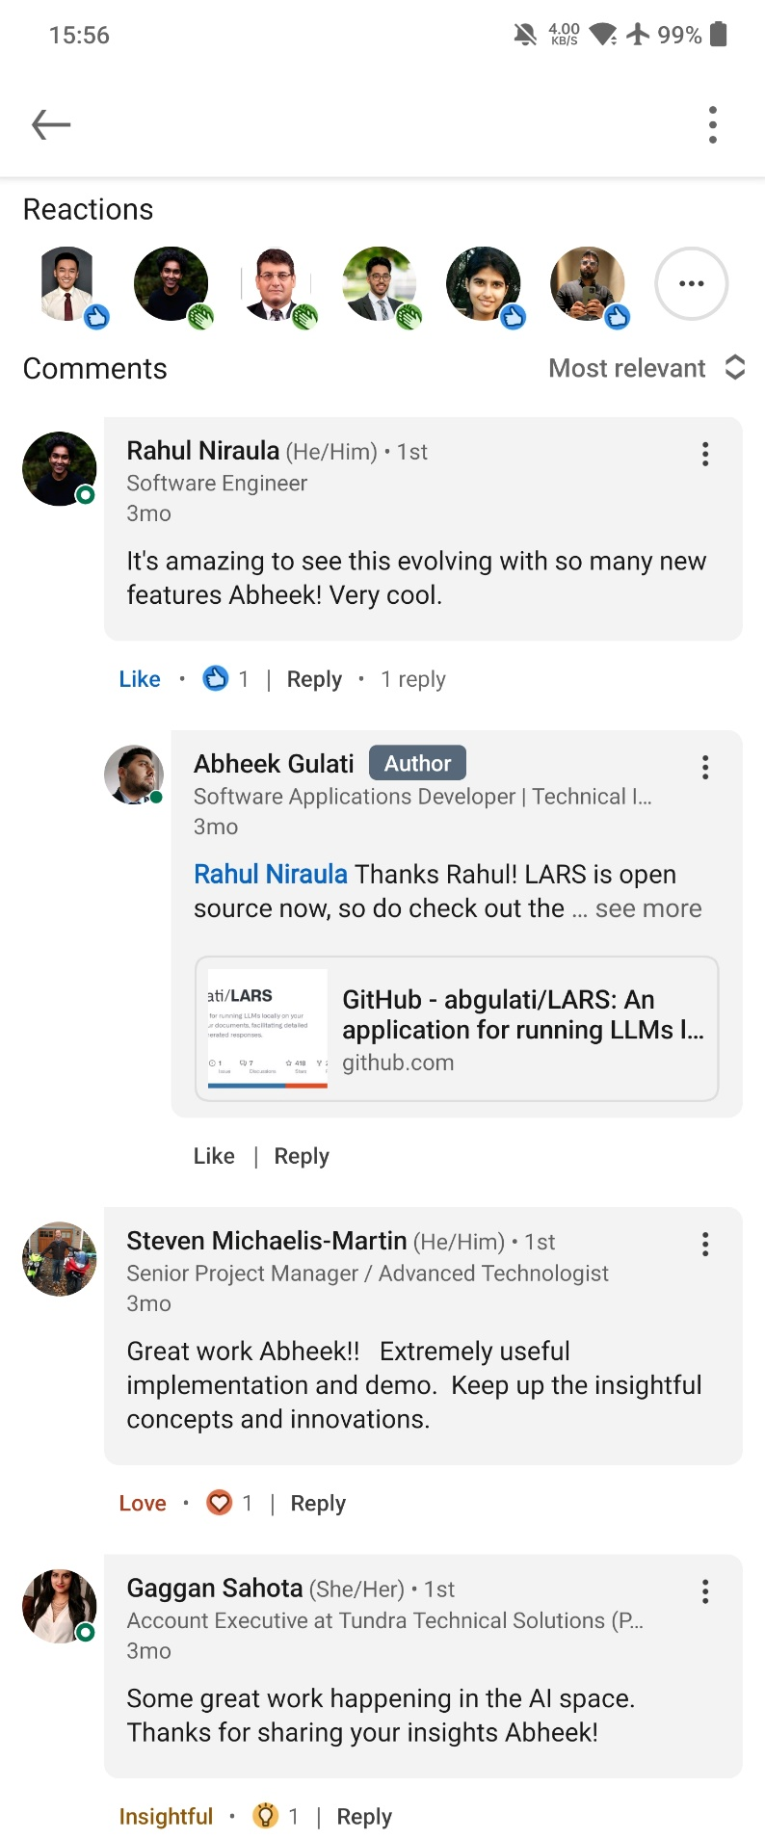

LARS Post 2

Link: https://www.linkedin.com/posts/abheek-gulati_github-abgulatilars-an-application-for-activity-7209673296252989441-JT4L

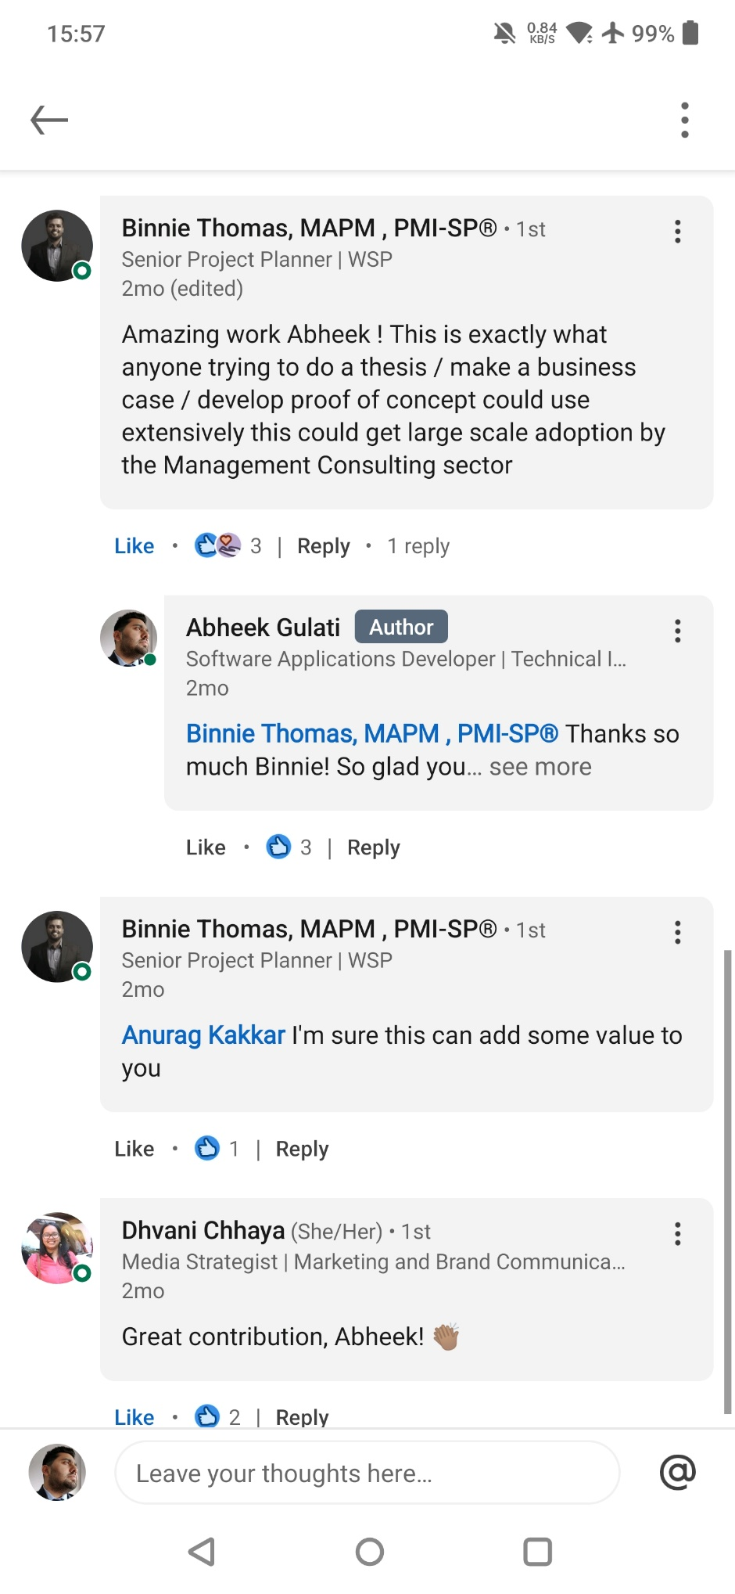

AI-OCR Post – Microsoft Kosmos-2.5 MLLM

Link: https://www.linkedin.com/posts/abheek-gulati_github-abgulatikosmos-25-containerized-activity-7219828896697835520-oOrp

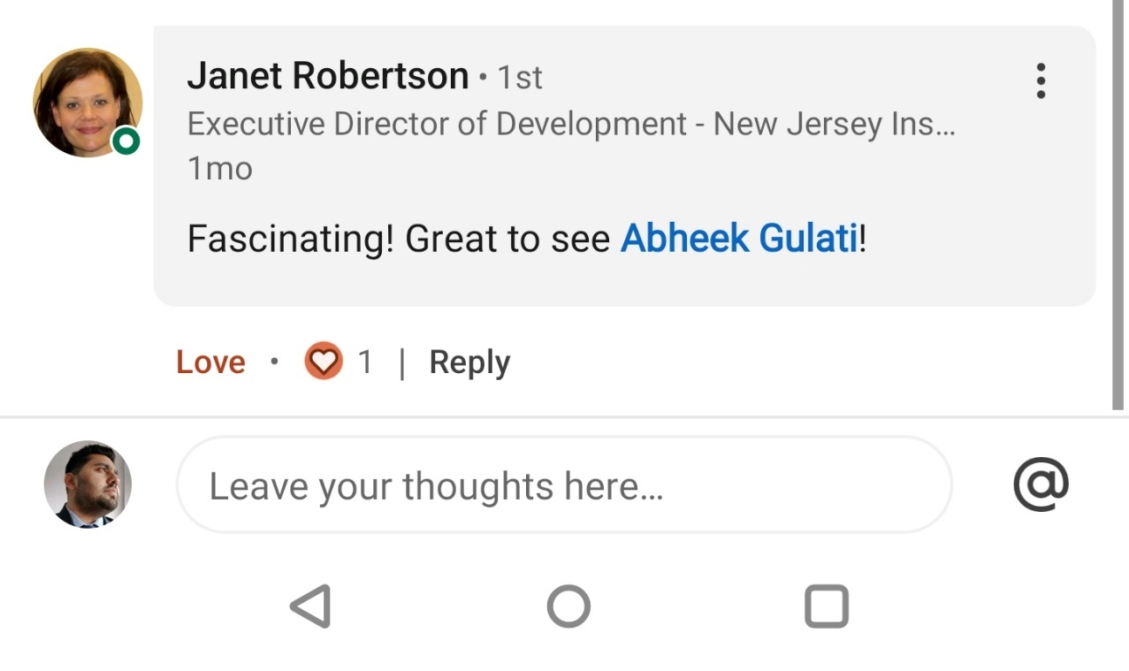

HF-Waitress Server Application Post

Link: https://www.linkedin.com/posts/abheek-gulati_github-abgulatihf-waitress-serving-llms-activity-7229267549874446336-SgCV

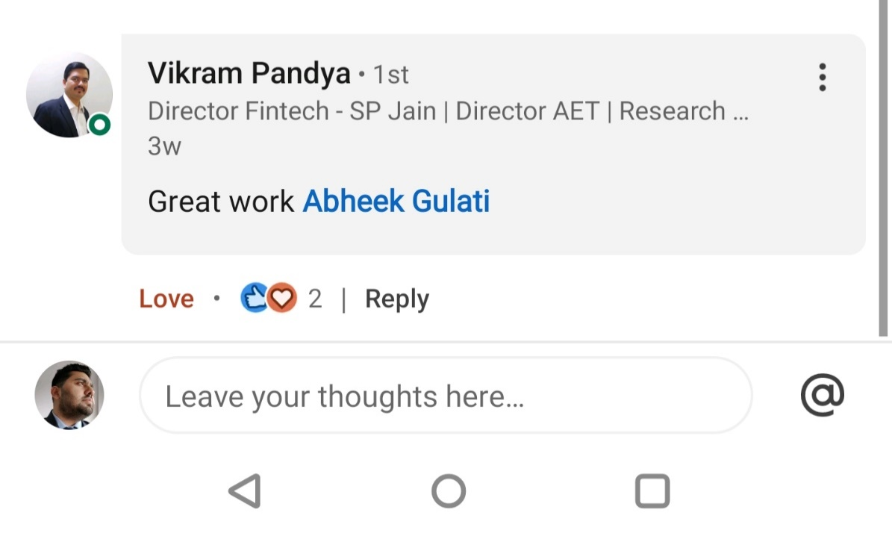

YouTube – LARS Demo Video – 2671 Views

Link: https://www.youtube.com/watch?v=Mam1i86n8sU
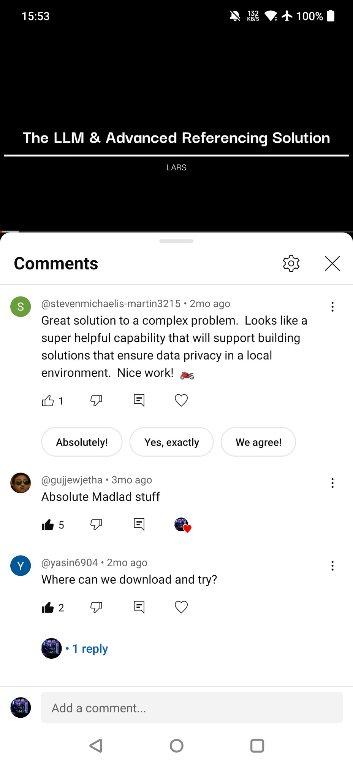

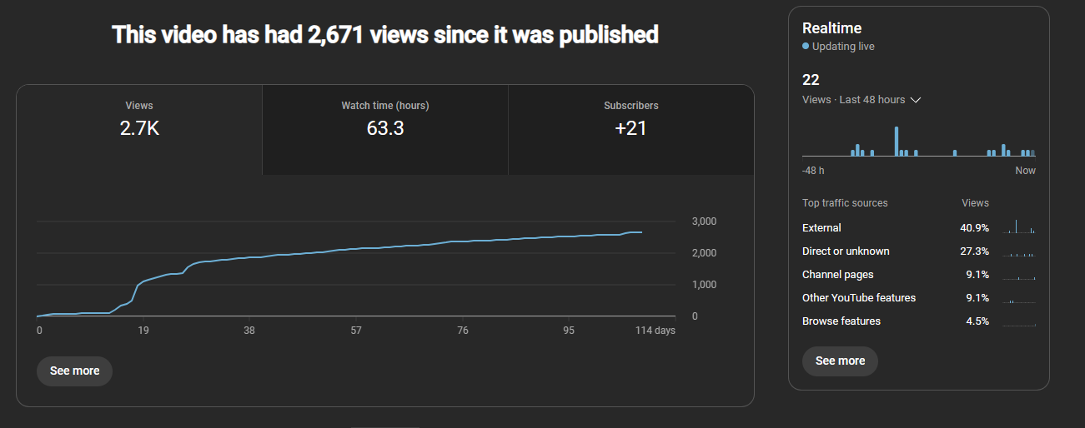

GitHub

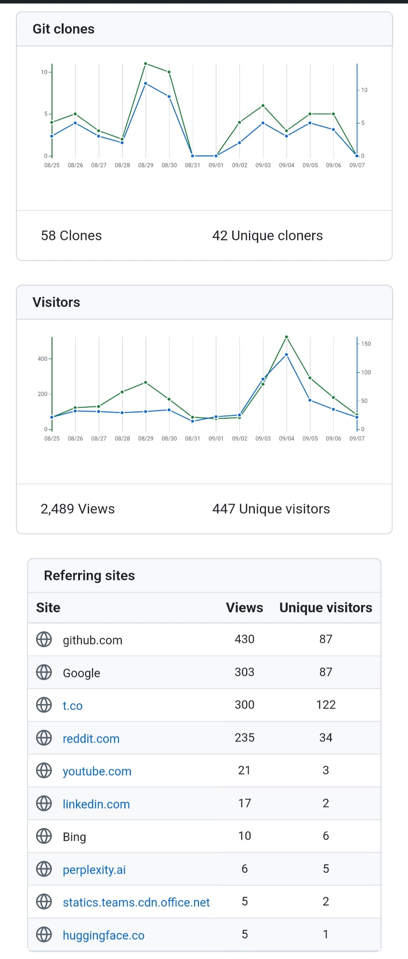
LARS – 451 Stars and 2489 Views

Link: https://github.com/abgulati/LARS

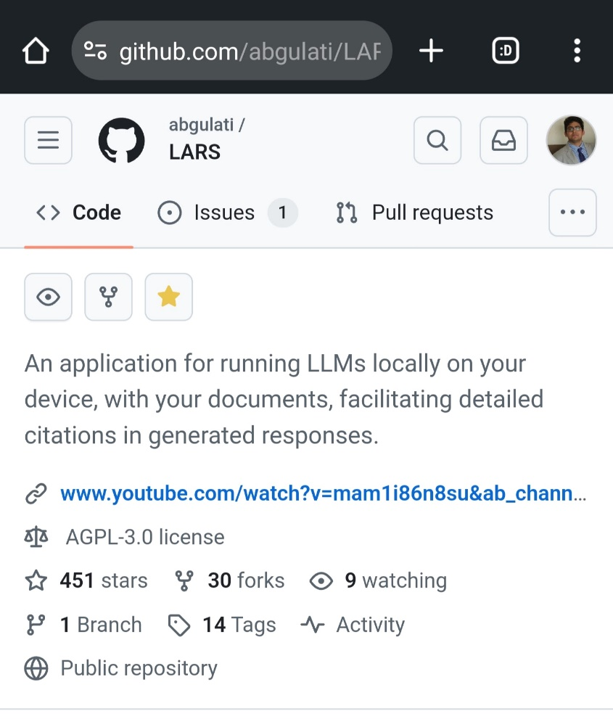

HF-Waitress – 67 Stars and 410 Views

Link: https://github.com/abgulati/hf-waitress
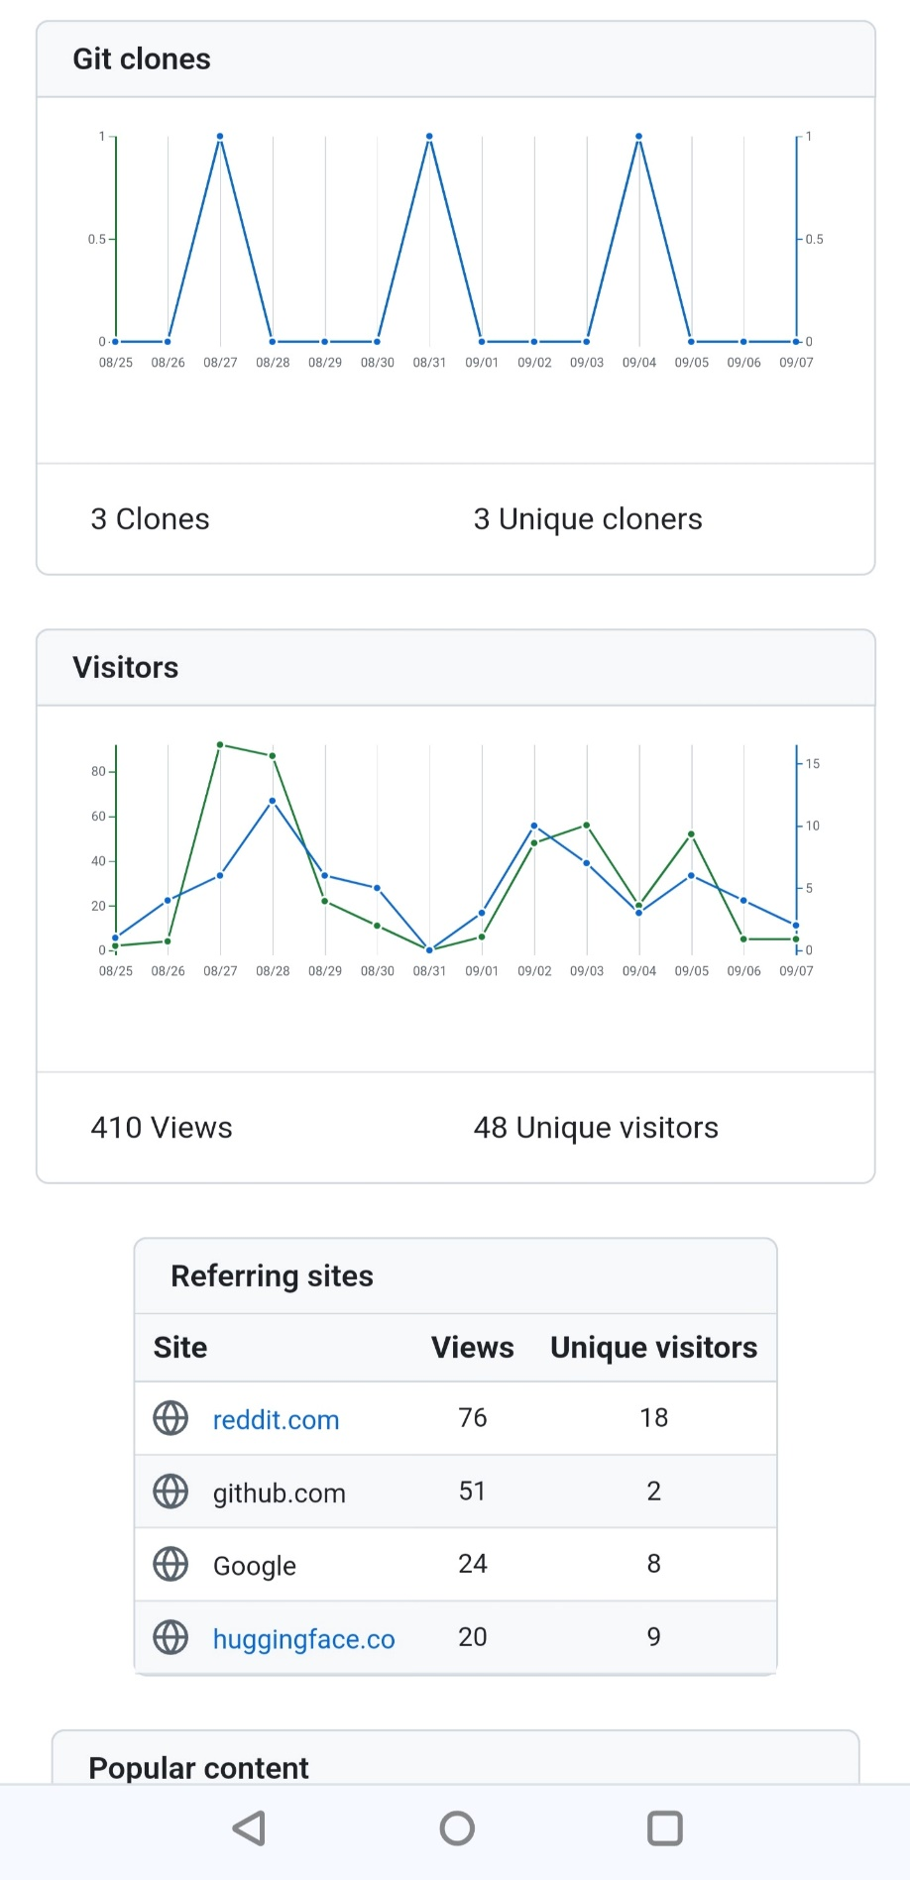

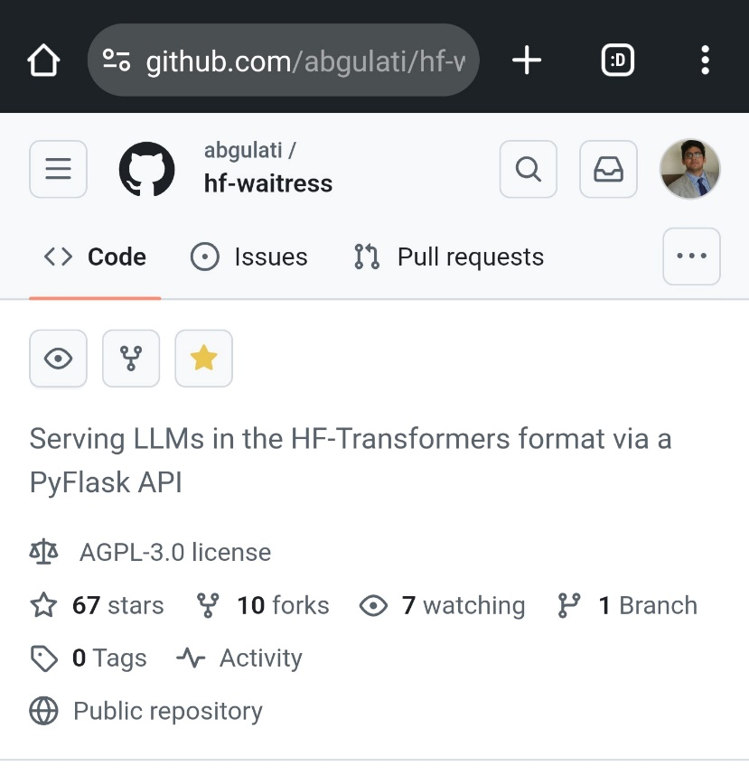

HF-Waitress – Acknowledgment from HuggingFace Staff

Link: https://github.com/huggingface/transformers/issues/32478

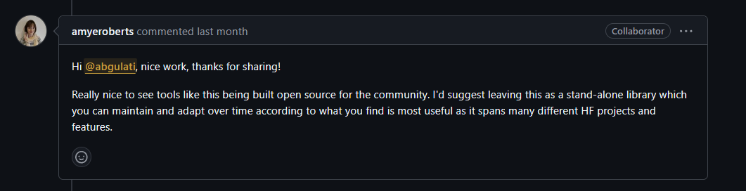

AI-OCR Kosmos 2.5 – 40 Stars and 117 Views

Link: https://github.com/abgulati/kosmos-2_5-containerized

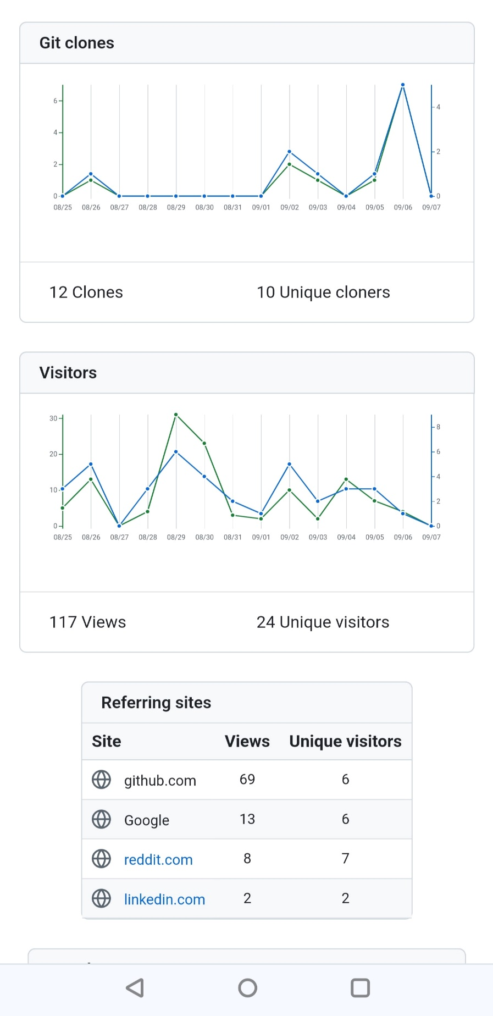
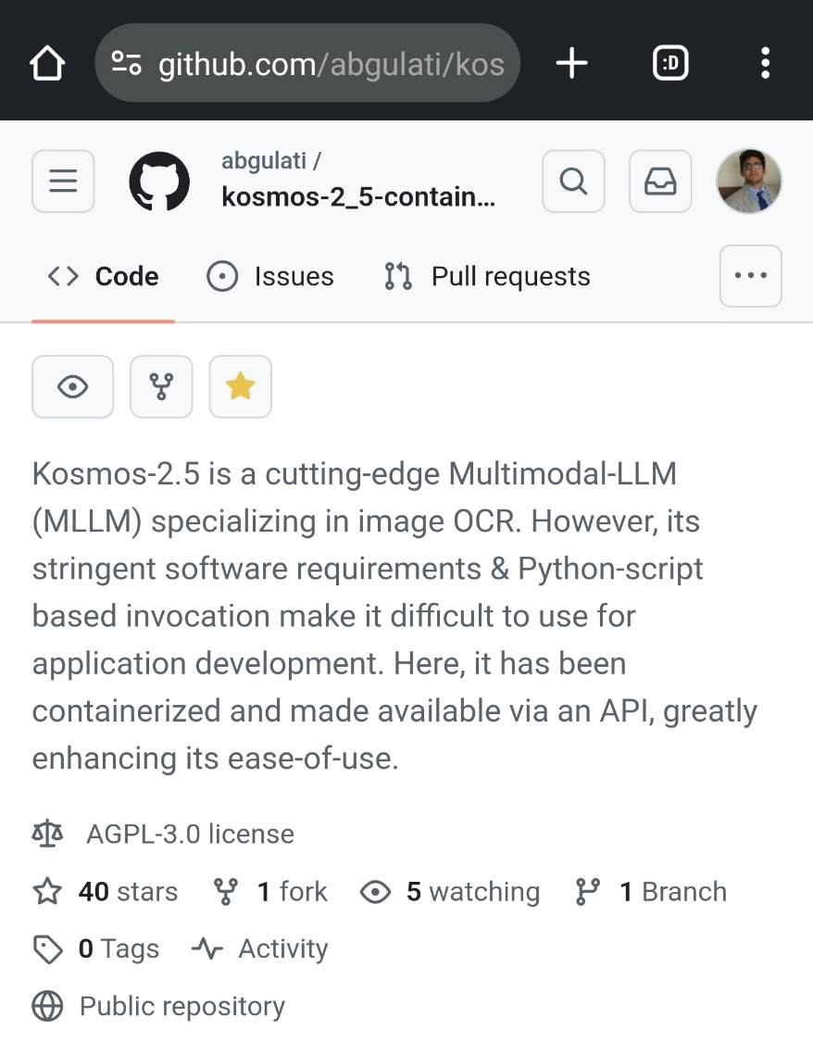

Reddit – Post Statistics

LARS Post 1 – 194,000 Views, 132 Likes & 179 Shares

Link: https://www.reddit.com/r/LocalLLaMA/comments/1bsfsc1/rag_for_pdfs_with_advanced_source_document/

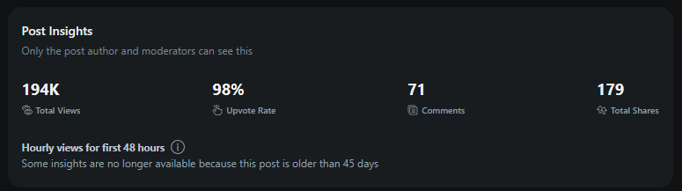

LARS Post 2 – 52,000 Views, 198 Likes and 259 Shares

Link: https://www.reddit.com/r/LocalLLaMA/comments/1db98el/rag_for_documents_with_advanced_source_citations/

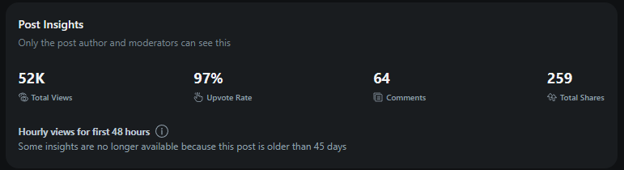

HF-Waitress Post – 68,000 Views, 236 Likes and 252 Shares

Link: https://www.reddit.com/r/LocalLLaMA/comments/1eijqc6/the_softwarepain_of_running_local_llm_finally_got/

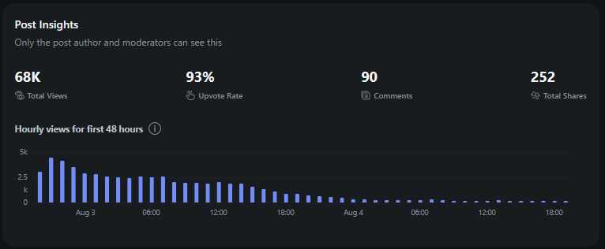

AI-OCR Kosmos-2.5 Post – 21,000 Views, 87 Likes and 79 Shares

Link: https://www.reddit.com/r/LocalLLaMA/comments/1e2l5ll/who_remembers_microsofts_kosmos25_multimodalllm/

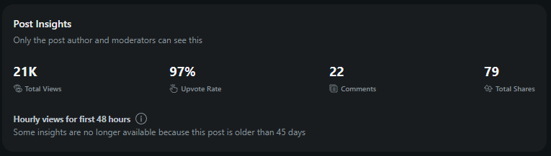

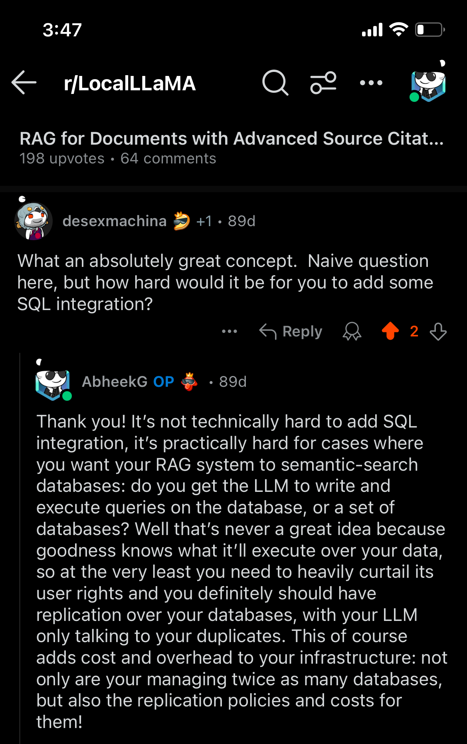
Reddit – Feedback

LARS

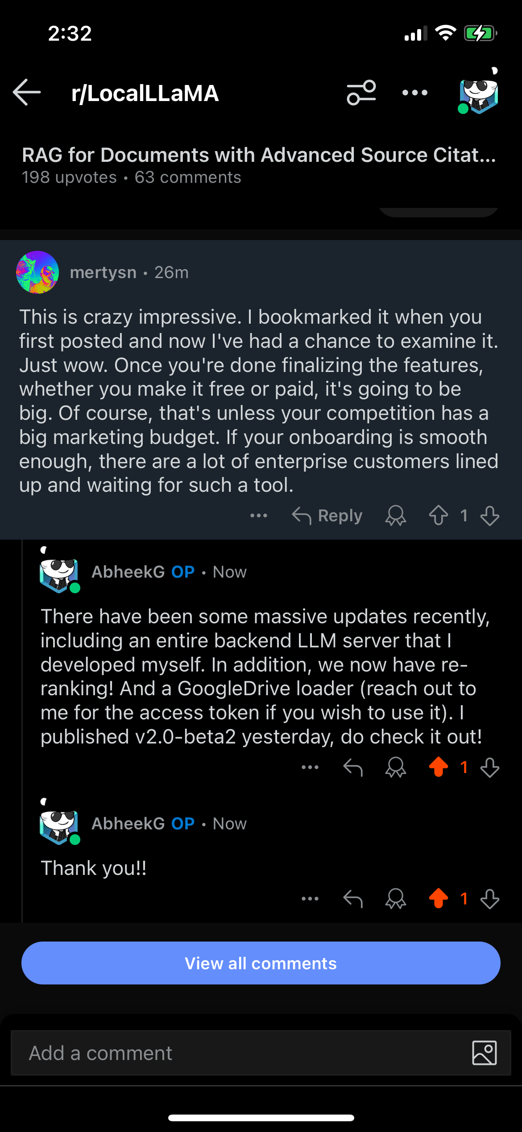

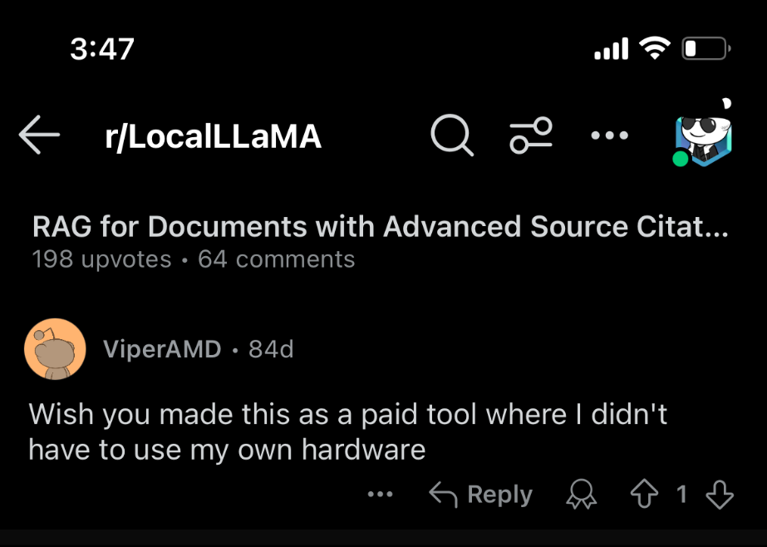

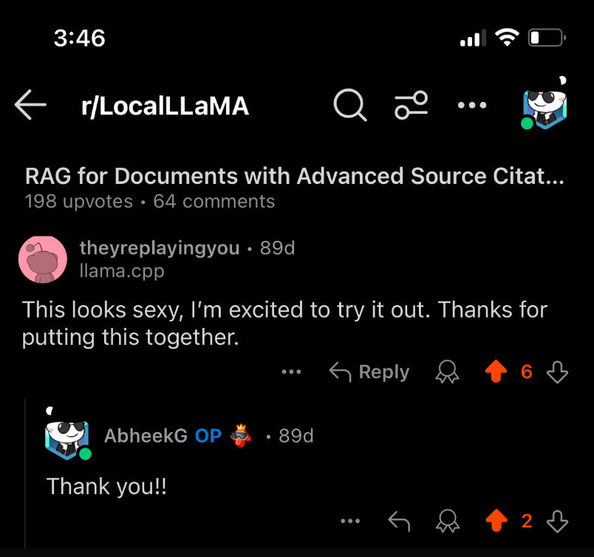

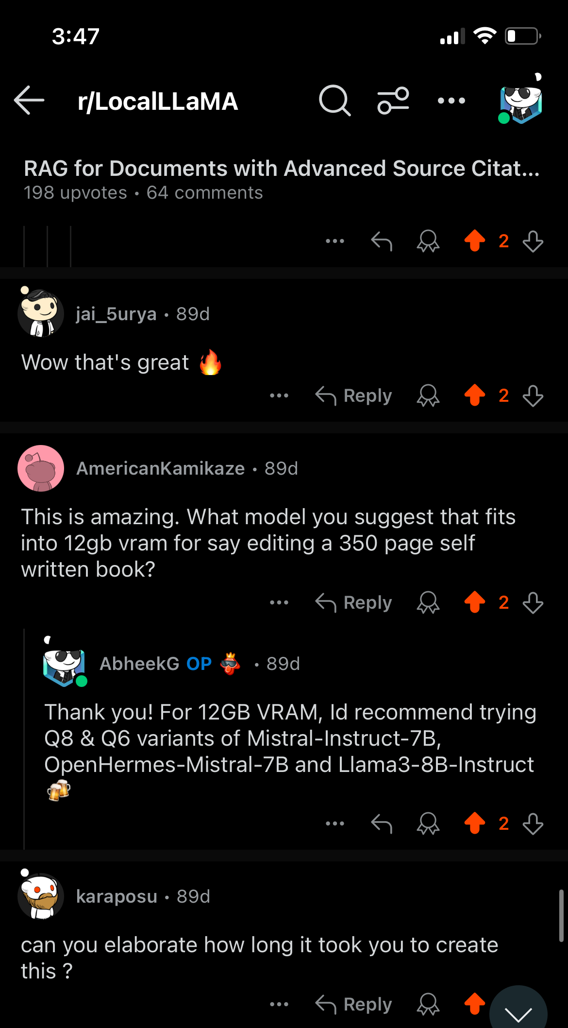

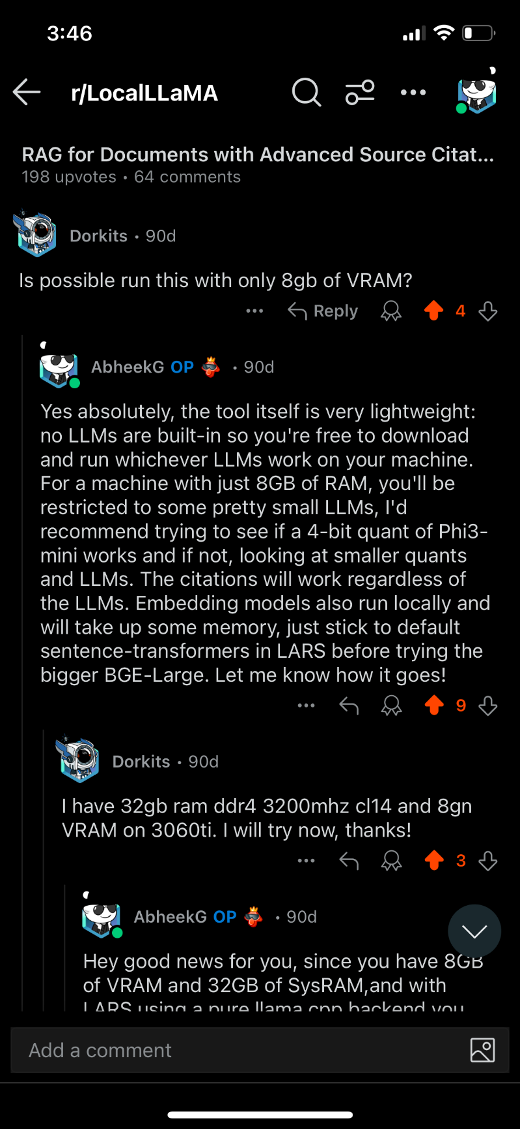

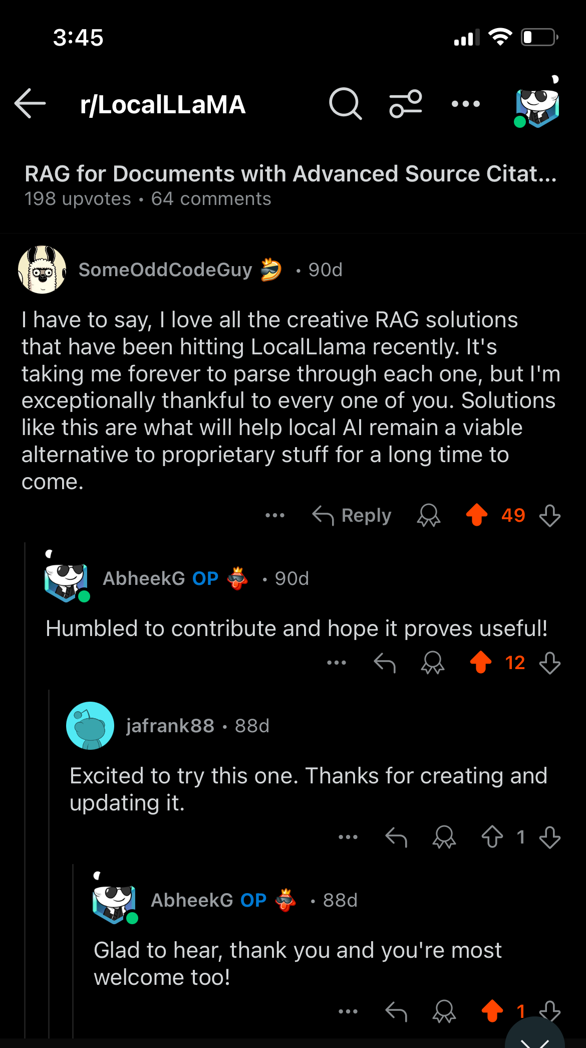

HF-Waitress LLM Server Application

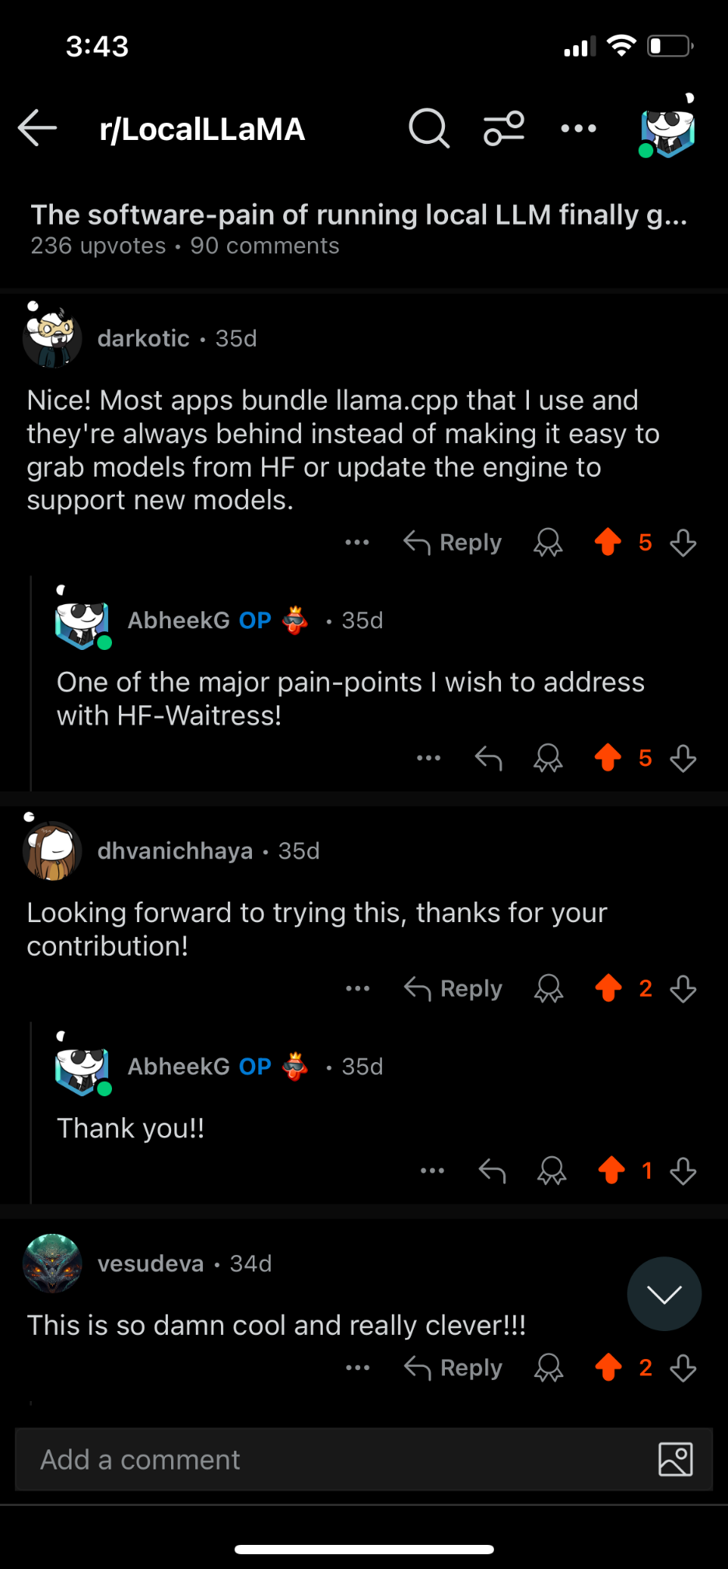

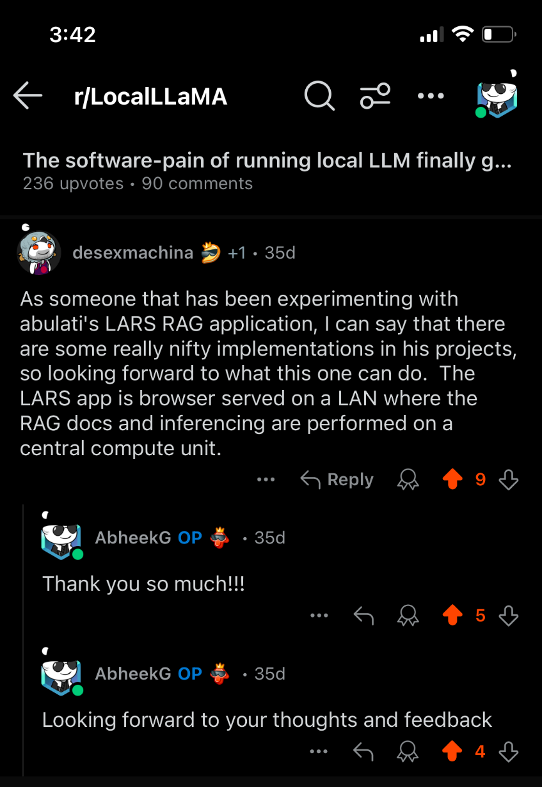

AI-OCR Kosmos-2.5

